This file will provide official CELPIP core evaluation principles and sample answers, scores, response analysis

**CORE EVALUATION PRINCIPLES 3**

**RESPONSE ANALYSIS. Writing Part 1 6**

Writing task 1. Question prompt. 6

Sample response 1. Part 1 - score 7-8 7

Sample response 1. Part 1 analysis 7

Sample response 2. Part 1 - - score 11-12 8

Sample response 2. Part 1- analysis 10

**RESPONSE ANALYSIS. Writing Part 2 11**

Writing task 1. Question prompt. 11

Sample response 1. Part 2 - score 7-8 11

Sample response 1. Part 2 - analysis 13

Sample response 2. Part 2 - score 9-10 14

Sample response 2. Part 2 - analysis 15

**MORE SAMPLE TASKS, LEVEL DESCRIPTORS, THEIR REAL SCORES AND SCORES’ ANALYSIS 17**

**Task A: Writing an Email 17**

**Task B: Responding to Survey Questions 17**

**CLB 0-2 18**

LEVEL DESCRIPTORS 18

SAMPLE ANSWERS 18

Response analysis CLB 0-2 19

**CLB 3 19**

LEVEL DESCRIPTORS 19

SAMPLE ANSWERS 20

Response analysis CLB 3 20

**CLB 4 21**

LEVEL DESCRIPTORS 21

SAMPLE ANSWERS 22

Response analysis CLB 4 22

**CLB 5 24**

LEVEL DESCRIPTORS 24

SAMPLE ANSWERS 24

Response analysis CLB 5 25

**CLB 6 26**

LEVEL DESCRIPTORS 26

SAMPLE ANSWERS 27

Response analysis CLB 6 27

**CLB 7 29**

LEVEL DESCRIPTORS 29

SAMPLE ANSWERS 29

Response analysis CLB 7 30

**CLB 8 31**

LEVEL DESCRIPTORS 31

SAMPLE ANSWERS 32

Response analysis CLB 8 33

**CLB 9 34**

LEVEL DESCRIPTORS 34

SAMPLE ANSWERS 34

Response analysis CLB 9 35

**CLB 10 37**

LEVEL DESCRIPTORS 37

SAMPLE ANSWERS 37

Response analysis CLB 10 38

**CLB 11 39**

LEVEL DESCRIPTORS 39

SAMPLE ANSWERS 40

Response analysis CLB 11 41

**CLB 12 42**

LEVEL DESCRIPTORS 42

SAMPLE ANSWERS 42

Response analysis CLB 12 43

# 

# CORE EVALUATION PRINCIPLES

# 

# 

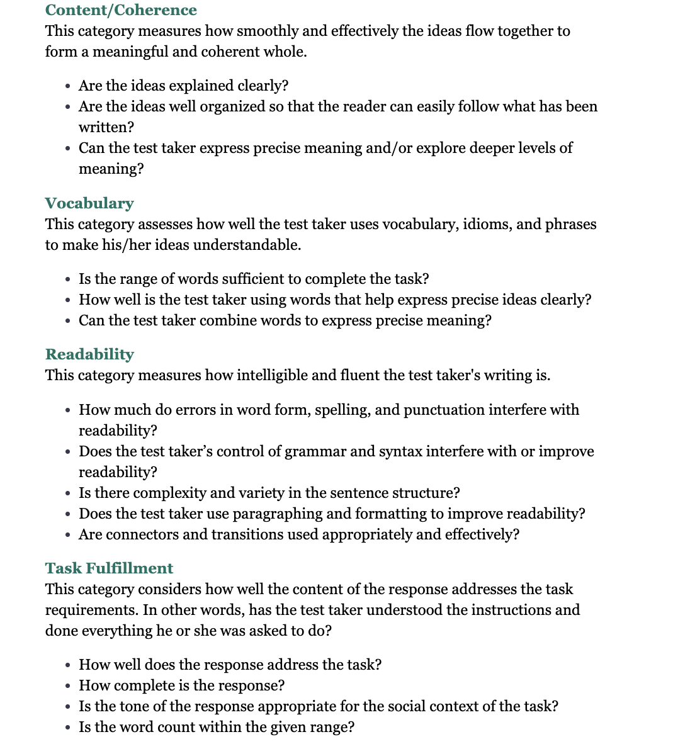

# RESPONSE ANALYSIS. Writing Part 1

In this section, there will be a writing task 1, 2 sample answers and their scores and analysis on each criterion. Almost all of it is in screenshots.

## 

## Writing task 1. Question prompt.

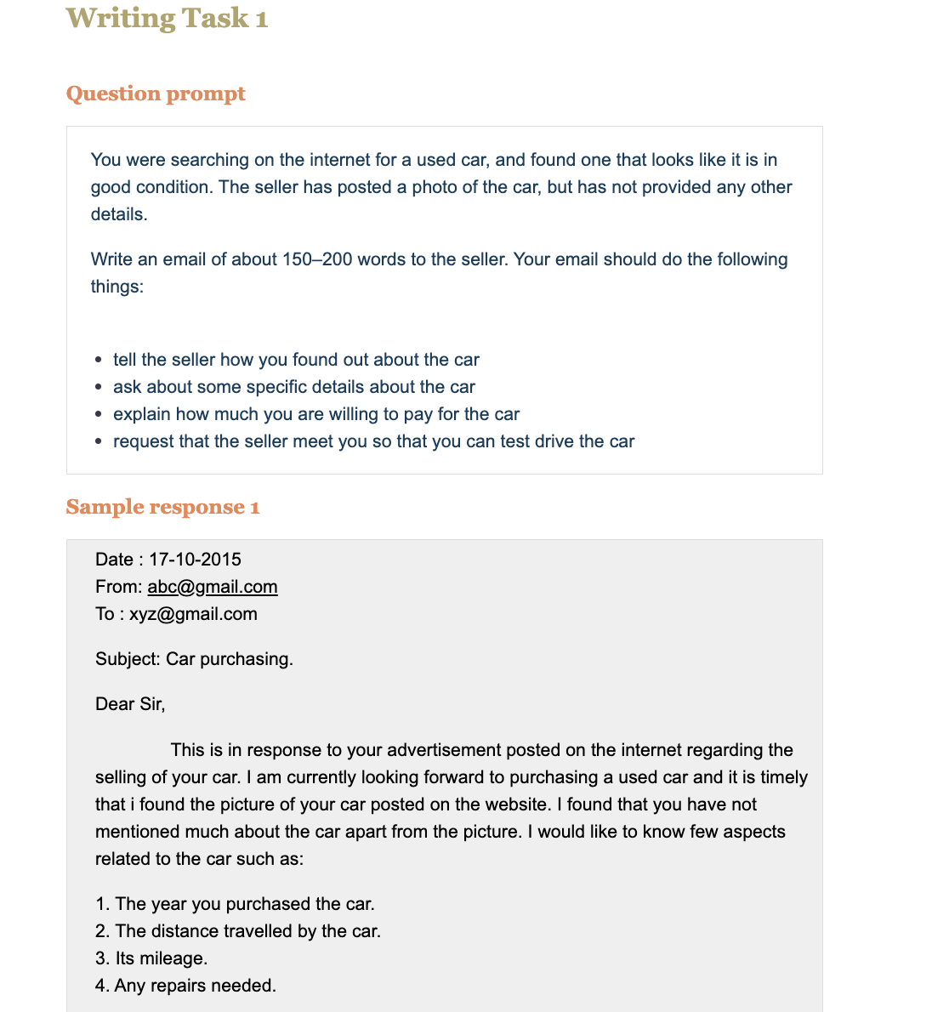

## Sample response 1. Part 1 - score 7-8

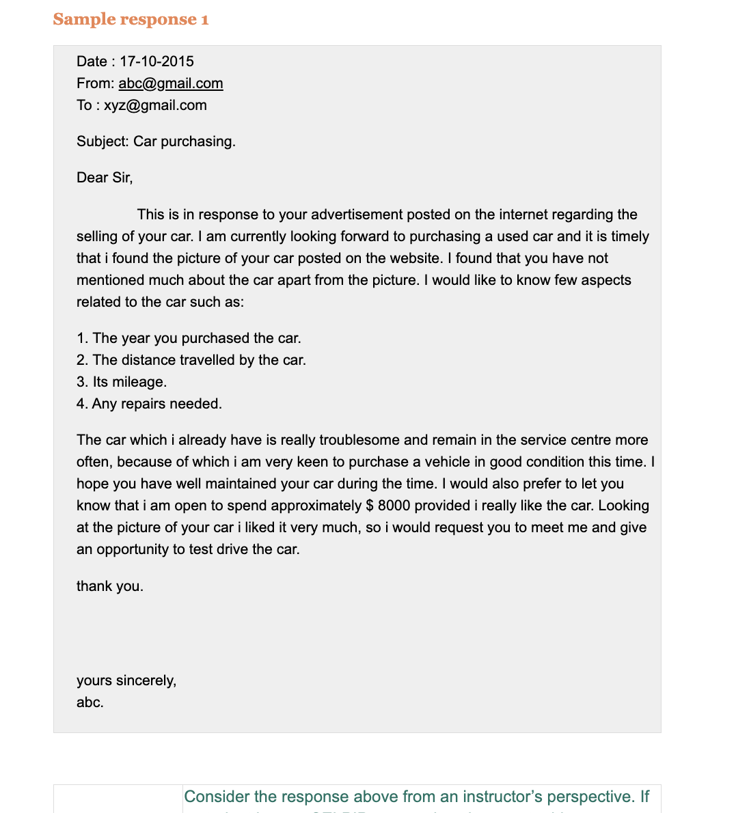

## Sample response 1. Part 1 analysis

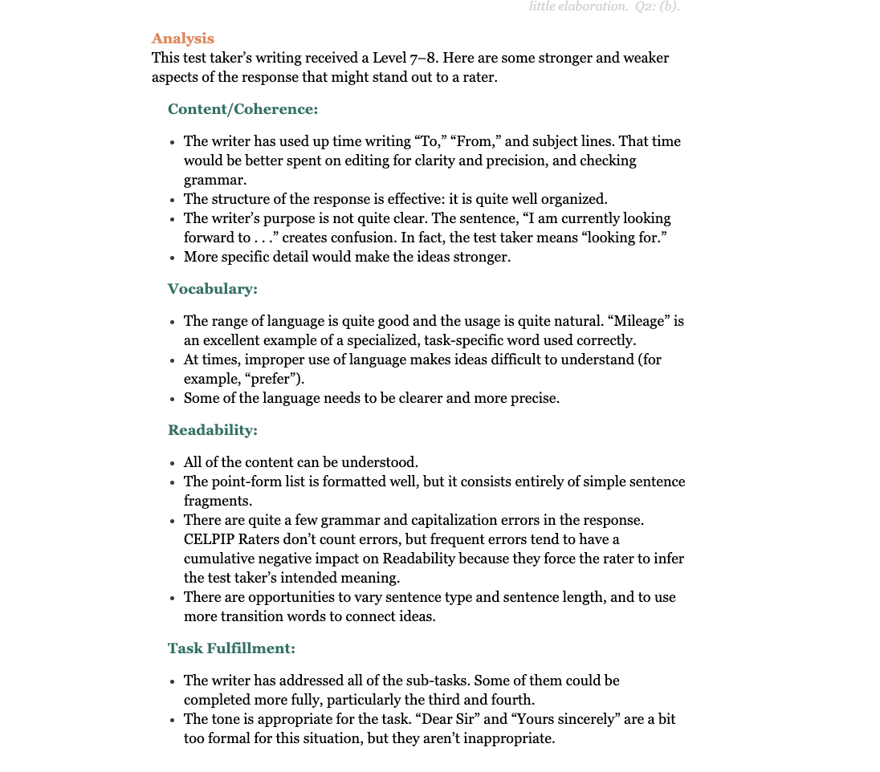

## 

## Sample response 2. Part 1 - - score 11-12

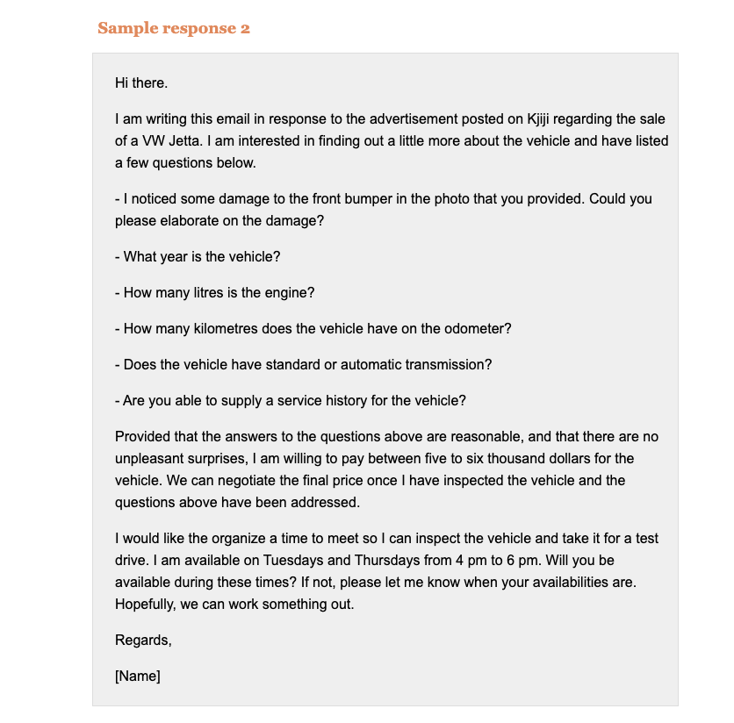

## Sample response 2. Part 1- analysis

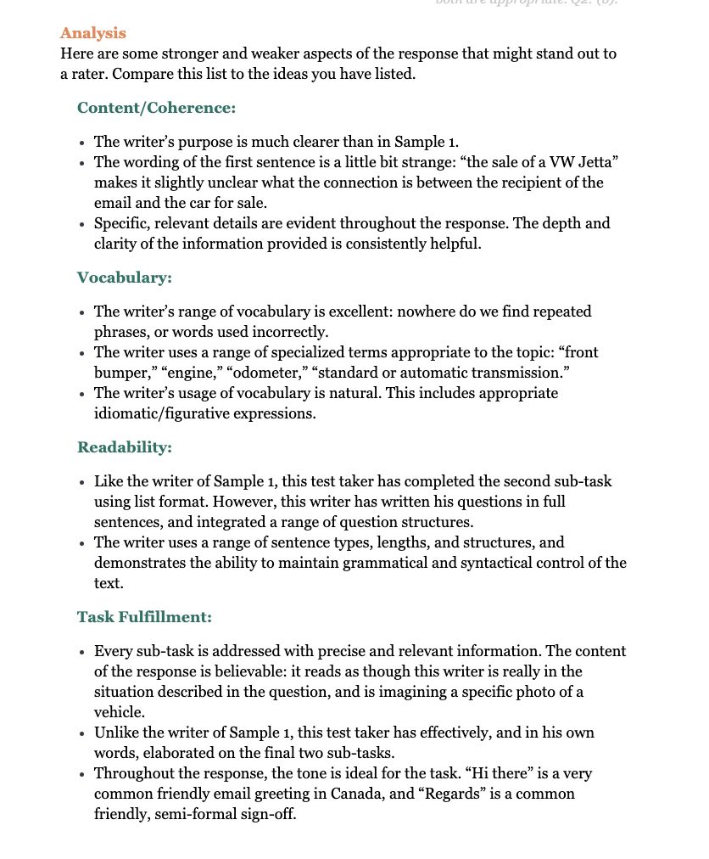

# RESPONSE ANALYSIS. Writing Part 2

## Writing task 1. Question prompt.

# 

## Sample response 1. Part 2 - score 7-8

# 

## Sample response 1. Part 2 - analysis

# 

## Sample response 2. Part 2 - score 9-10

## Sample response 2. Part 2 - analysis

# MORE SAMPLE TASKS, LEVEL DESCRIPTORS, THEIR REAL SCORES AND SCORES’ ANALYSIS

This section has more examples and each level sample response (from 0 to 12). There are task a (task 1 CELPIP), task b (Task 2 CELPIP) and 12 sample responses along with level descriptors and score analysis.

# Task A: Writing an Email

You use the local public library several times every week. However, the library is closed on Sundays and Mondays. You think the library should be open every day.

Write an email to the chief librarian in about 150–200 words. Your email should do the following things:

Describe the importance of the library for you.

Explain why the opening hours don’t work for you.

Suggest how people could use the library if it were open every day.

# 

# Task B: Responding to Survey Questions

Mail Delivery Survey

The government wants to either make people pick up their own mail at the post office or have it delivered only twice a week. This will save the government money. The government is asking your opinion of the change.

Choose the option that you prefer. Why do you prefer your choice? Explain the reasons for your choice. Write about 150–200 words.

Option A: I prefer to get my mail at the local post office.

Option B: I prefer to have mail delivered to my home twice a week.

# CLB 0-2

## LEVEL DESCRIPTORS

Content/Coherence  
At this level, I can:  
Write very short, simple phrases

Vocabulary  
At this level, I can:  
Write the alphabet and numbers  
Use very common words

Readability  
At this level, I can:  
Rarely use correct grammar

Task Fulfillment  
At this level, I can:Write some very simple information about me  
When:I write for or to a familiar person

## SAMPLE ANSWERS

Sample Response A

Very important aim need this books for school ,

because aim do not needed Sundays and Mondays .

Use awry day except Sundays and Mondays.

Sample Response A

Very important aim need this books for school ,

because aim do not needed Sundays and Mondays .

Use awry day except Sundays and Mondays.

## Response analysis CLB 0-2

Content/Coherence

Writers can use simple phrases. Examples in Task A include “books for sale” and “except Sundays and Mondays,” and in Task B, ”coming home.”

Vocabulary

Writers can use very common words. Some examples in Task A are “books,” “school,” and “day.”

Readability

Writers rarely use correct grammar. This makes the ideas difficult or impossible to understand. Tasks A and B contain no grammatically correct sentences.

Task Fulfillment

Writers can express very simple information about themselves. The information in both tasks is simple and personal (e.g., “Aim spend allots time with may children”).

# CLB 3

## LEVEL DESCRIPTORS

Content/Coherence

At this level, I can:

Write short, simple sentences

Vocabulary

At this level, I can:

Use very common words

Readability

At this level, I can:

Sometimes use correct grammar

Use capital letters and some punctuation

Task Fulfillment

At this level, I can:

Write some information about me

When:

I write for or to a familiar person

## SAMPLE ANSWERS

Sample Response A

Dear chief librarian

My name is Jeremy Patel, I hope you will be filling very good at this moment.

I and my family live and work in Edmond. WE very like to reed, that why we use the local public library several times every week. I study English with my wife and my daughter, eight years old likes to read science works and other.

I with my wife can to cam to the public library only on Sundays, but however, the library is closed. After work usualy I have not

Sample Response B

Dear government,

My name is Jeremy Patel, I leave in Edmond, 7 Maple St.

I prefer to get my mail at the local post office.

Everyday, when I came from the work, I can pick up my own mail at the post office, because I am wait everyday from my lots of friends their mail and other to me. If government wants to either make people pick up their own mail at the post office or have it delivered only twice a week, I choose to get my mail at the post office, because any way this will save the government money, I am understand that.

So, in other choice I see next, I will can not to read everyday my mail from my frinds.

## Response analysis CLB 3

Content/Coherence

Writers can produce short, simple sentences. An example is “I and my family live and work in [town name]” in Task A. Some of the sentences in Tasks A and B appear longer, but they are in fact run-on sentences resulting from misused punctuation.

Vocabulary

Writers can express ideas using common words. For example, Task A includes “very good,” “like,” “my wife,” and “my daughter.”

Note: The vocabulary used in Task B sometimes seems more sophisticated, but this is because the writer has copied key phrases—in fact, entire sentences—from the question and the two options: “I prefer to get my mail at the local post office,” “The government wants to either make people pick up their own mail at the post office or have it delivered only twice a week,” “save the government money.”

Readability

Writers can sometimes use correct grammar. These responses are noticeably more readable than the Level M examples below. Note, however, that the grammatically correct phrases and sentences in Task B are copied from the question, as mentioned in the Vocabulary analysis above.

Writers can use capital letters and some punctuation. Most sentences in Tasks A and B begin with a capital letter and end with a period.

Task Fulfillment

Writers can express some information about themselves. Aside from the material taken from the question and the options, the information communicated in both tasks is simple and personal.

# CLB 4

## LEVEL DESCRIPTORS

Content/Coherence

At this level, I can:

Write simple sentences and short, simple paragraphs

Communicate personal information

Vocabulary

At this level, I can:

Use common words

Readability

At this level, I can:

Write with some control of simple grammar

Use capital letters and simple punctuation

Task Fulfillment

At this level, I can:

Use some common phrases that are appropriate to the situation

Convey some information about very familiar topics

When:

I write for or to a familiar person

## SAMPLE ANSWERS

Sample Response A

Hi,my name is Gareth!

I will try to tell you about my problem. Why do not work library on Sundays and Mondays?

I use the local public library every day when it local public library is opening,and I think the local public library should be open every day.I like read books and I like riding books in the library,because in the library is a quiet and my brain there is relaxed. If you can duet everything about my problem please help me and answer me trough my e mail.I think local public library will have much more people witch like reading books in the library. Thank you!

Sample Response B

My name is Gareth!

I will tray to explain why I prefer to get my mail at the local posts office.

I think if I get my mail at the local posts office it is better or delivered only twice a week,because the government like that save money,save deliver trucks and cars,save postman.If my mail delivered to my home twice a week I think government will spend to much money and to much time.I think to much of people think like me and I think this question about post mail is very good for changes some in this Country.My suggestion is for all people in this Country need to writing mail for prefer to get post mail at the local post office. Thank

## Response analysis CLB 4

Content/Coherence

Writers can produce simple sentences and short, simple paragraphs. In Tasks A and B, the ideas are organized into simple paragraphs.

Writers can communicate some personal information. For example, in Task A, the writer explains what he likes to do at the library and why.

Vocabulary

Writers can use common words. In Tasks A and B, the vocabulary is common, and in some cases repetitive: the repetition of “local public library” and “read books (in the library)” in Task A, and the repetition of “save,” “to much,” and several phrases from the question in Task B.

Readability

Writers can sometimes use simple grammar correctly. Only one sentence in these responses has correct grammar throughout (“I will try to tell you about my problem” in Task A), but there are moments of correct or nearly correct grammar within some sentences: e.g., “I use the local public library every day,” “I think this question about post mail is very good.”

Writers can use capital letters. In both Task A and Task B, every sentence begins with a capital letter, and there are few errors in capitalization (e.g., “Country” in Task B).

Writers can use simple punctuation. Punctuation is used in both tasks, but with persistent errors in spacing; e.g., “…I think the local public library should be open every day.I like read books…” (Task A).

Task Fulfillment

Writers can use some appropriate common phrases. For example, Task A includes “please help me” and “answer me trough my email,” and Task B includes “it is better,” “spend to much money,” and “My suggestion is.”

Writers can convey some information about very familiar topics. In Task A, the writer states that he likes the library “because in the library is a quiet and my brain there is relaxed.”

# CLB 5

## LEVEL DESCRIPTORS

Content/Coherence

At this level, I can:

Write short, simple to moderately complex texts

Express a main idea and some related ideas

Vocabulary

At this level, I can:

Use common words and phrases

Readability

At this level, I can:

Connect two or more related ideas

Write with good control of simple grammar

Write with adequate control of spelling and punctuation

Task Fulfillment

At this level, I can:

Use common phrases that are appropriate to the situation

Convey some information about familiar topics

When:

I write for or to familiar people

## SAMPLE ANSWERS

Sample Response A

Dear chief librarian,

The reason for I’m write this email is because I think that the library is very important for all people, it is a place where people can be study, learn and relax. I think is one of the most important place into a community and the education.

I need explain that I work every day long, and every week long too, and I don’t have much time en weekdays for go to the library, just I have some free time on weekends, and is the only place where actually I can relax and enjoy reading a interesting book or something especial.

I suggest and ask you, if it is possible keep open the library on weekends also. I’m sure people could be use more frecuently, and perhaps, can be use for more younger people as a place for to make homework, also on weekends.

Regards.

Sample Response B

I prefer to have mail delivered to my home twice a week.

I think it is not necessary more than that time because anyway I go for my mail once or twice a week. In general, I don’t have more time for pick it up, and I suppose that people do it the same way.

I think it’s not many people need for mail every day, obviously should be exceptions, but if with this action we can save money as a country, I think is a good decision, because is not a big change in your life, and we will necessary be adapt our habits, just a minimum change for maybe better quality in health, educaction, etc,

I think many people support that choice and I hope will be a good choice

## Response analysis CLB 5

Content/Coherence

Writers can express a main idea and some related ideas. Tasks A and B each express main ideas and some related ideas (supporting details, examples, etc.). The attempt at related ideas in Task B is less successful than in Task A: the phrase “I go for my mail once or twice a week” is not clear, considering that the mail is currently being delivered and the writer is asking for it to continue to be delivered. Coherence decreases further in the second paragraph: it isn’t clear what the writer means by “a minimum change for maybe better quality in health, educaction, etc.”

Vocabulary

Writers can use common words and phrases. There is a noticeably broader range of vocabulary in Tasks A and B than in the Level 4 responses below, not only because the Level 5 responses are longer but because the vocabulary use here is more varied.

Readability

Writers can connect two or more related ideas. Tasks A and B include appropriate, though fairly simple, transitions and conjunctions; e.g., “and,” “because,” “if,” and “In general.” The use of transitions is somewhat more effective and sophisticated than in the Level 4 responses below.

Writers have adequate control of punctuation. In Tasks A and B, the writer makes one particular error several times by using commas where there should be periods. However, the ideas are comprehensible despite the errors.

Task Fulfillment

Writers can use common phrases that are appropriate to the situation. For example, Tasks A and B include the phrases “I suggest,” “if it is possible,” “Regards,” “I suppose that,” “a good decision,” and “support that choice.”

Writers can convey some information about familiar topics. The Task A sample focuses on familiar personal information. For this reason, the ideas in Task A are more relevant and better supported than in the Task B sample, where the writer attempts to express more abstract, less personal concepts but does so with less supporting details.

# CLB 6

## LEVEL DESCRIPTORS

Content/Coherence

At this level, I can:

Write short, coherent texts

Express a main idea with some supporting details

Vocabulary

At this level, I can:

Use common words and phrases

Readability

At this level, I can:

Organize related ideas into paragraphs

Write with good control of simple grammar

Write with adequate control of spelling and punctuation

Task Fulfillment

At this level, I can:

Present information using a tone and style that are sometimes appropriate to the situation

Convey some factual information about a topic

When:

I write for or to a familiar or clearly defined audience

## SAMPLE ANSWERS

Sample Response A

Date: 13 june 2016

To: Chief Librarian

Topic: Importance of Library

I believe that library is very important in our society. Library is where we find all the information that want to see. It is important to everyone specially for the student to give an extra ideas and searching and learning from their assignments. Even for ordinary people is very useful and helpful. Sometime people will came to library to read books during their spare times and they feel good after they read their favourite books.

The library is closed every Sunday and Monday and it will not work for me. I am a full time employee and work in weekdays. And Sundays is just my spare time to visit library.

I hope that you will find a solution for the schedule of the opening Hours of the library special during

Sample Response B

I prefer to get my mail at the post office. It is also useful to me to come in the post office to pick my mail. Through this I am giving a small amount of contribution to the government. And by doing so, I believe that that government will do something in return in the society for the save money.

It also give benefit to me to get may mail in the post office to keep me updated on my daily routine.

And it also an extra time for me to walk and it will be good exercise to me. In this opinion it will help a lot to keep me updated to my mail and also to may bill payment.

## Response analysis CLB 6

Content/Coherence

Writers can produce short, coherent texts that express a main idea with some supporting details. Task B achieves this, as does Task A, despite being unfinished: the writer describes the problem and proposes a solution.

Vocabulary

Writers can use common words and phrases. In Tasks A and B, attempts to use more precise, colloquial, or context-specific language result in unclear ideas: e.g., “Sundays is just my spare time,” “a small amount of contribution,” “keep me updated on my daily routine,” and “in this opinion.”

Readability

Writers can organize related ideas into paragraphs. Both Task A and Task B are organized into paragraphs, though the paragraphing of Task A is more successful than that of Task B.

Writers have good control of simple grammar. Although both Task A and Task B contain errors, they usually do not prevent comprehension. Many of the errors arise from the same weakness: preposition use. Writers at this level may run into difficulties when attempting more complex structures: e.g., in Task A, “specially for the student to give an extra ideas and searching and learning from their assignments,” and in Task B, “do something in return in the society for the save money.”

Writers have adequate control of spelling and punctuation. The spelling is correct throughout both tasks. There are some punctuation errors, but they don’t have an ongoing negative impact on readability.

Task Fulfillment

Writers can present information using a tone and style that are sometimes appropriate. In Task A, a number of phrases use an appropriate tone and style, e.g., “Even for ordinary people is very useful and helpful” and “I hope that you will find a solution.” However, sometimes it is a bit too formal/essay-like (“library is very important in our society”), and sometimes it is too personal/simplistic for the context (“And Sundays is just my spare time,” “it also an extra time for me to walk”).

Writers can convey some factual information about a topic. Factual information is conveyed throughout the first paragraphs of Tasks A and B.

# CLB 7

## LEVEL DESCRIPTORS

Content/Coherence

At this level, I can:

Write short, moderately complex, factual texts

Express a main idea with supporting details

Vocabulary

At this level, I can:

Use common and some context-specific words to communicate meaning

Readability

At this level, I can:

Organize related ideas into paragraphs

Write with adequate control of complex grammatical structures

Write with good control of simple grammar, spelling, and punctuation

Task Fulfillment

At this level, I can:

Present information using a tone and style that follows most common writing conventions

Convey factual information about a topic

When:

I write for or to a familiar or clearly defined audience

## SAMPLE ANSWERS

Sample Response A

Respected Sir,

Library is the best source of information and knowledge, easily accessible to public. I visit library 4 to 5 times a week spending a minimum of 2 hours on each visit. I would like to put forth my request request to keep the library open every day of a week, in public interest.

People work in different environments with different schedule. For instance, my work shifts enables me to take Sunday/Monday offs whereas, my wife gets Saturday/Sunday offs. These are the days which are most comfortable and convenient us to visit and more time in library reading. But unfortunately, the public library is not open on Sundays and Mondays which keeps most of the public away from library especially on Sunday and for people like me on Monday too.

As said, library being the source of information for most of the public should be accessible to public every day to ensure we cover interests of interested people

Thanks,

XYZ

Sample Response B

I appreciate this move to reduce and save the money spent by government on mailing infrastructure. We live in a world ruled by electronic mails. Most of the communications from/to people happen via emails including the critical ones, so I believe there is a huge scope for cost savings, if we optimize the mail delivery system properly.

I would prefer the mails to be delivered to my home versus collecting them by myself since I work 7 days a week with shifts placed between 8 AM to 6 PM. This schedule does not permit me to collect the mails at the local post office with the commuting time accounted. Any material delivery can be easily handed over to my wife or mother at home and mails can be dropped into my personal mailbox installed at the door.

To conclude, I believe delivering mail twice a week would keep both government and public in a win-win situation saving significant money without causing inconvenience to the public. Mails still act as an important communication way

## Response analysis CLB 7

Content/Coherence

Writers can produce short, moderately complex, factual texts. In Tasks A and B, some of the ideas are complex; e.g., “Most of the communications from/to people happen via emails including the critical ones, so I believe there is a huge scope for cost savings, if we optimize the mail delivery system properly.” Other ideas in the responses are simpler: e.g., “People work in different environments with different schedule” and “to ensure we cover interests of interested people.” Overall, these responses demonstrate greater ability to support ideas factually and precisely than the Level 6 responses below.

Writers can express a main idea with supporting details. There is a clear purpose in Task A (“I would like to put forth my request request to keep the library open every day of a week, in public interest”). Task B also includes a main idea: “I would prefer the mails to be delivered to my home versus collecting them by myself.” In each task, there are details to support the main idea.

Vocabulary

Writers can use some context-specific words to communicate meaning. Examples from Tasks A and B include “put forth,” “public interest,” “source of information,” “accessible,” “optimize,” “does not permit me,” and “personal mailbox.” Word choice is noticeably more specific, accurate, and varied than in the Level 6 responses below.

Readability

Writers can organize ideas appropriately into paragraphs. Paragraphing is used appropriately in both of these responses, although the formatting—indenting each paragraph and leaving an empty line between each—is not ideal.

Writers can demonstrate good control of simple grammar, and developing control of complex grammar. There are errors throughout both Task A and Task B (missing articles, some missing/incorrect punctuation, some awkward syntax), but the ideas can still be understood.

Task Fulfillment

Writers can use a tone and style that follows most common writing conventions. The style of these responses is more consistent and suitable than that of the Level 6 responses below, where the tone occasionally becomes too formal and essay-like, or too simple and personal, for the situation.

# CLB 8

## LEVEL DESCRIPTORS

Content/Coherence

At this level, I can:

Write short, moderately complex texts

Develop a main idea with supporting details

Vocabulary

At this level, I can:

Use common or context-specific words to communicate meaning

Readability

At this level, I can:

Write well-organized paragraphs

Write with good control of complex grammatical structures, spelling, and punctuation

Task Fulfillment

At this level, I can:

Present information using a tone and style that follows common writing conventions

Convey and support my main ideas about a topic

When:

I write for or to a familiar or clearly defined audience

## SAMPLE ANSWERS

Sample Response A

Dear Chief Librarian,

I am writing to you with regards to the operating hours of your library. I would appreciate that the library committee will consider operating on Sundays and Mondays as well.

I am a regular patron of your library. I need to visit the library for my research and self study sessions required for my part time MBA course. Occasionally, I would be required to work late for meetings and overtime, and would not be meet the library operating hours. I could only use the library on Saturday, which is a day I would need to complete other household chores.

By opening your library daily, it can benefit not just me, but the entire community. Most families will spend their Sundays doing things together. The library can certainly organize story telling sessions or talks/workshops that are family friendly on Sundays. There are also many schools surrounding your library. Your library is an excellent place for highschoolers to hang out after school for self studies or project meetings. Therefore, there is every reason to open on Mondays too!

I hope my suggestions can be considered by the committee. I will look forward to your favourable response soon.

Regards

Wendy

Sample Response B

My option is to have my mails delivered to my home twice a week. Though it’s only twice a week, but it does not change my daily routine. We do not need to allocate time for post office pick up. Sometimes, both my husband and myself may be too occupied at work, and may miss picking up the mails. I sincerely do not want to miss out important mails for that reason.

Base on our mailing records, we do not receive mails daily. At least for relevant mails. We do have junk mails delivered daily, which is not favoured. We had opted for electronic mails for most of our banking and financial institutions. So we will not be expecting regular mails from them. Government bodies are also starting to mail electronically, which is the our preferred mode of correspondence. Twice a week of mail delivery is about right for our family. In fact, we do not require to clear our mailbox stuffed with junk mails everyday anymore!

## Response analysis CLB 8

Content/Coherence

Writers can develop a main idea with supporting details. Tasks A and B include an appropriate number of main ideas that are supported with specific details. There is more complexity in the ideas than in the Level 7 responses below. The supporting details are more specific and less repetitive.

Vocabulary

Writers can use common words and phrases appropriately. Examples in Task A include “work late,” “hang out,” “community,” and “every reason.” Examples in Task B include “at work” and “about right.” In both tasks, meaning is communicated more precisely through common language than in the Level 7 responses below. Ideas are expressed with more concise words and phrases.

Writers can use some context-specific words and expressions. In Task A, examples include “a regular patron” and “family friendly,” and in Task B, “junk mails,” “miss out,” and “preferred mode of correspondence.”

Readability

Writers have good control of complex grammatical structures, spelling, and punctuation. There are quite a few errors in both Task A and Task B, but they generally don’t impede comprehension of the ideas.

Task Fulfillment

Writers can present information in a tone and style that follows common writing conventions. These responses contain an appropriate mix of relevant personal information (e.g., the ideas concerning the writer’s school situation and work schedule in Task A) and ideas with a wider/less personal scope (e.g., the points about major institutions shifting to electronic communication in Task B). Examples of contextually appropriate style include “I am writing to you with regards to,” “I would appreciate,” and “I will look forward to your favourable response” in Task A, and “Both my husband and myself may be too occupied” in Task B.

# CLB 9

## LEVEL DESCRIPTORS

Content/Coherence

At this level, I can:

Write short formal and informal texts of some complexity

Support key ideas with relevant facts, descriptions, details, or quotations

Vocabulary

At this level, I can:

Choose words and phrases to provide accurate details, descriptions, and comparisons

Readability

At this level, I can:

Write well-organized paragraphs

Write with control of a range of complex and diverse grammatical structures

Write with good control of spelling and punctuation

Task Fulfillment

At this level, I can:

Present information using a tone and style that follows some formal and most informal writing conventions

Convey my intended meaning

When:

I write for a defined audience and the situation is formal or informal

## SAMPLE ANSWERS

Task A: Writing an Email

You use the local public library several times every week. However, the library is closed on Sundays and Mondays. You think the library should be open every day.

Write an email to the chief librarian in about 150–200 words. Your email should do the following things:

Describe the importance of the library for you.

Explain why the opening hours don’t work for you.

Suggest how people could use the library if it were open every day.

Sample Response A

To whom it may concern,

My name is Seth and I am writing to you today regarding the opening hours for the library. I am an English student and my course requires me to read many books throughout the year. As a result, I visit the library several times a week to rent the required books. Books can be very expensive, so the library is a great benefit to me as instead of spending lots of money buying these expensive books I can rent them instead at a much lower cost.

I have recently started a new part-time job. Now, my only days off are Sundays and Tuesdays. The library is closed on Sundays which leaves Tuesday evenings after school as the only time I can visit the library. As the library closes early on Tuesdays, I have to rush down after school. This is very stressful for me and it would be much easier if the Library was open on Sundays as then I would have all day to visit.

I feel that many other people have the same problem and would benefit greatly if the library was open every day. I hope you will consider this.

Thanks,

Seth

Sample Response B

I would prefer to have my mail delivered to my home twice a week as opposed to me collecting it myself at the local post office. The reason I would prefer this is because I have a very busy schedule and having to collect my own mail from the post office would just take up more of my spare time. Also, the closest post office to my house is a twenty minute walk. I do not own a car so I would have to walk this distance in order to collect my mail.

I feel that having my mail delivered to my home twice a week is a more efficient way of delivering mail to homes as it limits the amounts of trips the post office has to take in order to deliver mail. This in turn will save money for the government as instead of spending money on gas and wages for the employees that deliver the mail every day, they will be only spending this money two days per week.

These are the reason I would prefer to have my mail sent out to my home twice a week.

## Response analysis CLB 9

Content/Coherence

Writers can write short formal and informal texts of some complexity. Both of these texts are complex, and the complexity is more consistent than in the Level 8 responses below.

Writers can support key ideas with relevant facts, descriptions, details or quotations. In Tasks A and B, ideas are supported both with relevant personal details (e.g., the information about school and work schedules in both tasks), and with facts/descriptions (e.g., the explanation of the results of cutting back mail service in Task B).

Vocabulary

Writers can choose words and phrases to provide precise details, descriptions, and comparisons. Here the writer’s vocabulary facilitates communication of accurate details about both personal matters and broader issues. There are few errors in vocabulary, the most noticeable one being the use of “rent” instead of “borrow.” Words that effectively indicate a comparison are used in Task B: “as opposed to,” “more efficient.”

Readability

Writers can produce well-organized paragraphs. Each paragraph in Task A and Task B contains one clear main idea that is developed with supporting details in an easy-to-read way.

Writers have control of a range of complex and diverse grammatical structures. Control of grammatical structures is noticeably stronger in these responses than in the Level 8 responses below: there are some errors here, but they are infrequent and have a minimal impact on readability. The writer creates complex sentences using a range of structures, including conditional and hypothetical statements (e.g., “it would be much easier,” “if the library was open every day”) and a wide variety of transitions and conjunctions (e.g., “as a result,” “as,” “instead of,” “in turn”).

Writers have good control of spelling and capitalization. There are noticeably fewer punctuation errors than in the Level 8 responses below.

Task Fulfillment

Writers can present information using a tone and style that follows some formal and most informal writing conventions. The tone of both responses is consistently appropriate. In each response, the writer uses many standard phrases and devices for more formal correspondence; e.g., “I am writing to you today regarding…,” polite use of modal verbs (e.g., “it would be much easier,” “would benefit greatly”), and clear opening and closing statements.

Writers can convey their intended meaning. In each response, the writer successfully conveys everything they intended to communicate. This is true even though Task A is somewhat incomplete (the third sub-task is not addressed) and off topic (the second paragraph focuses on Tuesdays, not Mondays).

# CLB 10

## LEVEL DESCRIPTORS

Content/Coherence

At this level, I can:

Write short formal and informal texts of some complexity

Support key ideas with a range of facts, descriptions, details, or quotations

Vocabulary

At this level, I can:

Choose words and phrases to provide precise details, descriptions, and comparisons

Readability

At this level, I can:

Connect ideas and make transitions within and between paragraphs

Write with good control of a range of complex and diverse grammatical structures

Task Fulfillment

At this level, I can:

Present information using a tone and style that follows most formal and informal writing conventions

Convey my intended meaning

When:

I write for a defined audience and the situation is formal or informal

## SAMPLE ANSWERS

Sample Response A

Dear Chief Librarian,

I use the local public library several times a week to research material, and access word processing for my studies. Access to the library is integral to my schooling, and as such, flexible opening hours are vital.

I recently started a part-time job which requires me to cover shifts on the weekend, and varying week days. Unfortunately, this restricts my ability to access the library given the current opening hours. I feel that if the hours were extended to be open 7 days a week, it would enhance the experience of many patrons.

For many people, the library is a place of leisure and recreation; as such, if it were to open on both Saturday’s and Sunday’s, kids and adults alike could enjoy the enriching activities offered at your facility over the entire weekend. 7 day access would make this possible for all persons, regardless of their weekly work/study structure.

Thank you for reviewing this request, and I hope you will consider extending opening hours to 7 days a week.

Kind regards,

Vanessa

Sample Response B

I would prefer option B be implemented, rather than option A. The convenience of having mail and packages delivered to my home outweighs the option of ready access to the items at my own discretion.

Typically I only check the mail box at my apartment 2-3 times a week, so the delivery restrictions would not affect me greatly. So long as there were assigned delivery days, I would be able to obtain my mail at regular intervals and not waste time checking an empty post box.

If option A were implemented, the onus to collect the post would be on me. Realistically, there wouldn’t be time to make the trip to the post office more than once or twice a week, which makes option B all the more appealing.

The time saving method of mail delivery (option B) is a much preferred option. Please c

## Response analysis CLB 10

Content/Coherence

Writers can support key ideas with a range of facts, descriptions, details, or quotations. Task B includes a number of contextually suitable facts (e.g., “If option A were implemented, the onus to collect the post would be on me“). Task A includes support in the form of descriptions (e.g., the third paragraph) and details (e.g., the first paragraph). Task B is incomplete, but the text is still coherent: its purpose is fully and clearly expressed.

Vocabulary

Writers can choose words and phrases to provide precise details, descriptions, and comparisons. Tasks A and B demonstrate a wider range of vocabulary than the Level 9 responses below. The word choice is more varied, concise, and precise; e.g., “integral,” “enriching activities,” “ready access,” “at my own discretion,” “the onus,” and “realistically.” In Task B, the writer also uses an array of comparative language; e.g., “The convenience…outweighs,” “all the more appealing,” and “much preferred.”

Readability

Writers can connect ideas and make transitions within and between paragraphs. A range of transitions and connectors are used appropriately throughout Task A and Task B to link ideas: e.g., “as such,” “given,” “So long as,” and “which.”

Writers have good control of a range of complex and diverse grammatical structures. These include subjunctive mood and conditional statements: e.g., “if it were to open” in Task A, and “If option A were implemented,” “So long as there were assigned delivery days,” and “there wouldn’t be time” in Task B.

Task Fulfillment

Writers can present information in a tone and style that follows most formal and informal writing conventions. A suitable level of formality is achieved in each task through considered use of vocabulary (e.g., “Thank you for reviewing this request,” “I hope you will consider,” “Please”) and grammatical structures (e.g., polite use of modal verbs).

# CLB 11

## LEVEL DESCRIPTORS

Content/Coherence

At this level, I can:

Write formal and informal texts for a range of purposes

Develop ideas with relevant facts, descriptions, details, or quotations

Vocabulary

At this level, I can:

Choose specialized, formal, and common words to express my meaning

Readability

At this level, I can:

Connect ideas and make transitions within and between paragraphs

Write with good control of a broad range of complex and diverse grammatical structures

Task Fulfillment

At this level, I can:

Present information using a tone and style usually appropriate to the situation

Accurately communicate my ideas

When:

I write for an undefined audience and the situation is formal or informal

## SAMPLE ANSWERS

Sample Response A

Dear Sir/Madam,

I am an avid user of my local public library. I visit the library several times a week, and would like to use it more, but I find the opening hours somewhat restrictive.

I am a single mother currently studying for a Masters at the Open University. As I am undertaking my studies from home, I don’t have access to a university library. Unfortunately I have very poor internet connection where I live and so rely heavily on the public library to conduct online research.

In addition, my daughter is book fanatic – she simply loves to read. Our favourite thing to do together is to spend time in the library at weekends. However, her swimming lessons have now been scheduled for Saturdays, on the opposite side of town. She does not have time to visit the library on the same day. As the library is closed on Sundays, we have to live without our weekly library visit together.

I feel the library should be open to the public every day of the week. It is an important resource for people looking for work, studying, or for those who simply wish to expand their minds.

B. Smith

Sample Response B

It is very important to me to have my mail delivered to my home. I have a very stressful job and often work long hours, well after the post office closing time. As I work such long hours, I tend to purchase most of my groceries and clothing online. Thus, I receive a lot of mail through the post.

There has been times where I have not been home to sign for a registered mail and have had to pick up a package from the post office. The post office is located down town on a street with very limited parking facilities. I often find myself circling the block several times waiting for a space to open up. On numerous occasions I have been forced to park in a loading zone, which has resulted in a parking fine more than once. Visiting my local post office, is both time consuming and expensive!

I must admit, I am not happy that the government plans to cut back on the postal service. If I must choose, I absolutely prefer to have mail delivered to my home twice a week, as opposed to not at all!

## Response analysis CLB 11

Content/Coherence

Writers can produce formal and informal texts for a range of purposes. Task A is appropriately formal for its situation: the writer uses a suitably respectful greeting to the Head Librarian and makes his request courteously. Likewise, in Task B, the writer maintains a polite register throughout the survey response.

Writers can develop ideas with relevant facts, descriptions, details, or quotations. Both responses achieve their purpose through an appropriate mix of personal details and more general/conceptual facts and ideas.

Vocabulary

Writers can choose specialized, formal, and common words to express their meaning. Examples of specialized language include “rely heavily” and “book fanatic” in Task A and “circling the block,” “loading zone,” and “parking fine” in Task B. Examples of formal language include “somewhat restrictive” (Task A) and “I must admit” (Task B). On some occasions, language choice could be more precise or varied: for example, in Task A, “studying for a Masters,” “spend time in the library,” and the repetition of “visit the library,” “work long hours,” and in Task B, “have mail delivered to my home.”

Readability

Writers can connect ideas within and between paragraphs. In Tasks A and B, this is achieved through many strategies, including conjunctions (“As”), transition words and phrases (“Unfortunately,” “I must admit,” “In addition,” “Thus”), and relative pronouns (“which”).

Writers have good control of a broad range of complex and diverse grammatical structures. Only minor errors occur in these responses: e.g., in Task A, “a Masters” and “my daughter is book fanatic”; in Task B, “There has been times,” “a registered mail,” ”down town,” and the unneeded comma after “local post office” in the second paragraph.

Task Fulfillment

Writers can present information using a tone and style that is usually appropriate to the situation. The tone suits the context in both Task A and Task B: among other strategies, the writer makes adept use of restrained language (e.g., “somewhat restrictive” in Task A and “I must admit” in Task B) to maintain appropriate formality. The tone of Task B is arguably less than ideal in some isolated places: the use of exclamation points, for example, could be considered inappropriate.

# CLB 12

## LEVEL DESCRIPTORS

Content/Coherence

At this level, I can:

Write complex formal and informal texts for a full range of purposes, intentions, and objectives

Develop ideas with relevant and sufficient facts, extended descriptions, details, or quotations

Vocabulary

At this level, I can:

Choose specialized, formal, and common words to express my precise meaning

Readability

At this level, I can:

Connect ideas and make transitions within and between paragraphs

Write with very good control of a very broad range of complex and diverse grammatical structures

Task Fulfillment

At this level, I can:

Present information using a tone and style appropriate to the situation

Precisely communicate my ideas

When:

I write for a diverse and undefined audience and the situation is formal or informal

## SAMPLE ANSWERS

Sample Response A

Dear Ms. Sonora,

My name is Charles Stevens. As a longstanding resident of the neighbourhood, I have had an Annex Library Card for two decades. I truly appreciate the work that you do as the Chief Librarian, in making it such an inclusive environment and fostering the local community.

Now, as a parent of two children (Gary, 6, and Sofia, 4) it is clear to me that the library’s service to the community could be enhanced if opening hours were extended to Sundays and Mondays. As you know, many families have sports activities and shopping scheduled on Saturday mornings. Sunday is the only day on which we could all enjoy the library’s play rooms, youth groups, and creative programs. Monday is the only night on which all member of the Annex Theatrical Troupe can practice in the auditorium.

These opinions are widely shared: parents at Annex Kindergarten are unanimous in their desire to share a Sunday cappuccino in the downstairs coffee shop, and to rehearse their lines in the auditorium on Mondays.

Please consider opening the library seven days a week; I hope to raise the issue at your next steering committee meeting.

Warm regards,

Charles Stevens

Sample Response B

There are two primary reasons that I prefer to pick up my mail at the local post office: security and availability.

As a person who regularly sends and receives confidential documents, security is a crucial aspect of my use of Canada Post. The standard mailboxes attached to duplexes in downtown Toronto are insecure. In contrast, the postal storage in Canada Post locations (and pharmacies throughout the city) are protected from casual theft.

The second primary reason that I prefer to pick up my mail is that, even though receiving the mail would require a short walk, it would remain available daily. In my line of work as a commissioner of oaths, two-day delay in receiving a document can be a serious professional problem. Furthermore, a good walk never did anyone any harm, even, perhaps especially, in the teeth of the February winter.

Finally, I would hope that — should the government institute the new pick-up-your-mail policy — they will also lengthen the hours at Canada Post locations, and broaden the range of pharmacies that can serve as mail handling locations.

## Response analysis CLB 12

Content/Coherence

Writers can compose complex texts for a full range of purposes, intentions, and objectives. Both Task A and Task B exhibit consistently high clarity, depth, and precision. Every sentence of Task A includes precise details, such as the name of the library, the programs it offers, and exactly who is hoping for a change in opening hours. These details strengthen the writer’s case for expanding the opening hours of the library. Likewise, Task B contains precise details about the writer’s profession and housing situation that fulfill the purpose of explaining why picking up his mail would be a more desirable option.

Writers can develop ideas with relevant and sufficient facts, extended descriptions, details, or quotations. All of the main ideas are developed thoroughly in both tasks. No examples of disorganized ideas, irrelevant details, or vague information can be found in either Task A or Task B.

Vocabulary

Writers can choose specialized, formal, and common words to express their precise meaning. The writer’s use of vocabulary is precise throughout both responses. The writer uses everyday language fluently, and uses specialized language where appropriate (e.g., “longstanding resident,” “inclusive environment,” “confidential documents,” and “commissioner of oaths”). There is even some figurative language: “never did anyone any harm” and “the teeth of the February winter.” The language use is overall more vivid and specific than in the Level 11 responses below.

Readability

Writers can connect ideas and make transitions within and between paragraphs. In both tasks, ideas are connected via transitions that communicate precise meaning and an appropriate tone: e.g., “Now” and “As you know” in Task A; “In contrast,” “The second primary reason,” and “Finally” in Task B.

Writers have very good control of a very broad range of complex and diverse grammatical structures. Tasks A and B contain longer and shorter sentences, sentences using a range of verb tenses, coordinate and subordinate clauses, a relative pronoun used as the object of a preposition (“the only day on which we could all enjoy”), and hypotheticals (“if the library’s opening hours were extended,” “should the government institute the new pick-up-your-mail policy”). The very few minor errors (e.g., the missing “s” in “member” in Task A and a couple of misused commas) have little/no impact on comprehension.

Task Fulfillment

Writers can present information using a tone and style appropriate to the situation. In both responses, the writer’s tone is not just appropriate but ideal. For example, in Task A, the statement of appreciation for the Chief Librarian “making it such an inclusive environment and fostering the local community” is directly applicable to the objective of arguing for expanded opening hours. In Task B, the personal information provided by the writer never exceeds the amount required for explaining why he prefers to pick up his mail.

# 